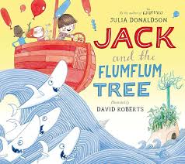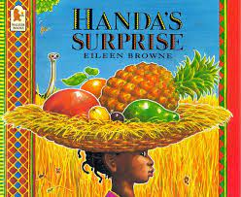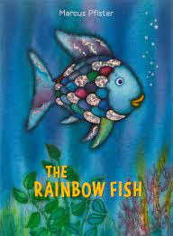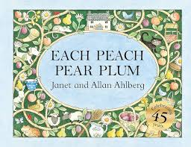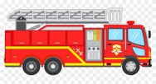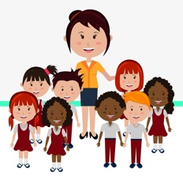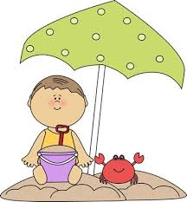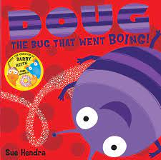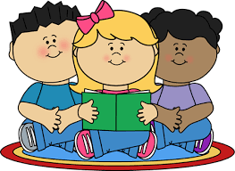

We will be talking about the season of ‘Summer’. Children will be observing the weather, and we will talk about other aspects of things we can do now the weather is better and we can get outside! We will talk about the clothes we need to wear and why and the types of food and drink we like to have to keep us fresh and hydrated.

During ‘Arts Week’ children will have further opportunity to develop their learning about imaginary places when we will be exploring this theme through art, drama, stories and singing with our two professional artists.

We will be working with many of our local Primary Schools to get the children ready for their transition into P1. Teachers will visit the children in nursery to get to know them before they start school in September.

Children will be given opportunities to identify and talk about people who are familiar to them in the local community and also those are not yet so familiar but may have an impact on their lives. For example: hairdressers, shop workers, police or fire service.

Children will be able to experience many different activities across all areas of the curriculum within this theme. Some will be ‘teacher led’ and some will be provided as independent learning opportunities.

Children will also be talking about places that they know about and enjoy visiting such as the park, the beach etc. They will have opportunities to explore this learning in a variety of ways such as through role-play, information books and stories etc.

**Our Core Books will be:**

**Key focus:** People and places, familiar and new, in the local community and beyond.

**People and places where I live**

