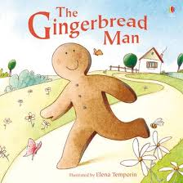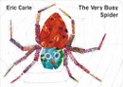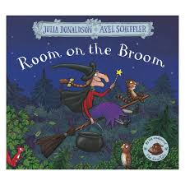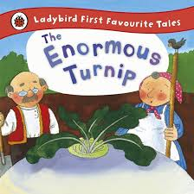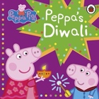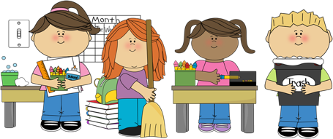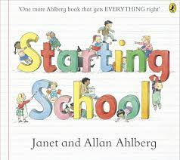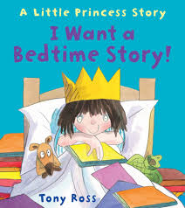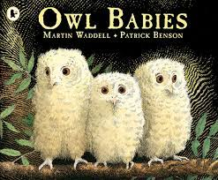

We will be reading lots of stories about settling into school. Also about making new friends, being kind to each other and exploring our feelings. Children will think about what makes them feel happy but also that it’s ok to feel scared or sad and what might help them to feel better.

The children will be learning how to use all the different areas in the classrooms. They will be shown how to select what they want to play with and how to get ready to paint. They will be able to label their work with their own name, find resources that they may need to use and use the toilets by themselves. They will select their snack and choose whether to drink milk or water.

We will meet with our children and their families at the Family Visit days. Children will have a photograph of their family in their classroom to look at and talk about. These pictures of familiar people stay in the room all year for the children to see and talk about every day if they want to.

Our focus for September and October is settling the children happily into school. Children will experience many new learning ideas, routines, and opportunities across all areas of the curriculum. Staff will be working with the children in many ways to support their varying levels of confidence, knowledge, and ability to familiarise them with their new school environment, meeting new people and making friends, and learning how to play and share. Children will learn our routines and develop independence and confidence in their new surroundings.

We will be introducing our Big Bedtime Read home packs after the Halloween break!

**Our Core Books will be:**

**Key focus:** Me and my family, making friends, my place in my world- settling into nursery school.

**It’s All About**

**Me!**

