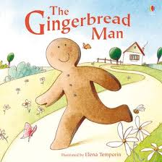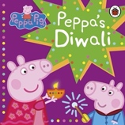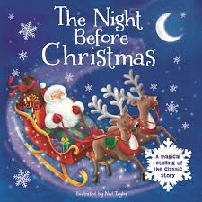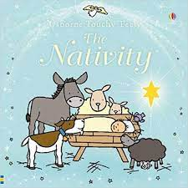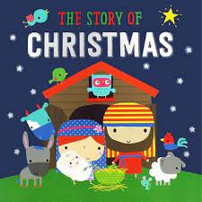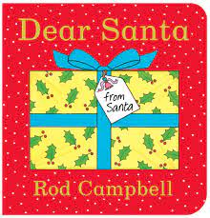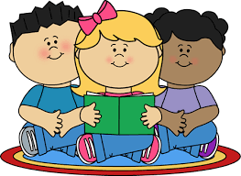

Children will also be creating artwork around their knowledge and experience of ‘Fireworks’ that they may have seen during the Halloween holidays. Opportunities to talk about the sounds they heard, the colours and the smells will be available. Children will be able to select a variety of materials to create their own artwork both individually and together in collaboration with their peers.

We will be launching our ‘Big Bedtime Read’ reading initiative on ‘Children in Need’ day. Children can wear spotty/Pudsey themed PJs on that day!

Children will have opportunities to participate in lots of different creative activities. We will be talking about our own Christmas traditions and how we celebrate the’ Festive Season’. Of course, we will be talking about Santa and making our Christmas lists! Children will also be hearing stories about the birth of Jesus and the first Christmas in Bethlehem. There will be lots of opportunities for the children to take part in a wide range of activities which develop all areas of the pre-school curriculum.

**Family celebrations in our community**

**Our Core Books will be:**

**Key focus:** As part of our “World Around Us” curriculum we discover with the children how people in both our culture, and others, mark special events during the year.

The Indian festival of ‘Diwali’ enables the children to begin to learn about other children in the world. The cultural side to the Festival of Light – Diwali has some similarities to our own customs, such as fireworks and candles, cards and special outfits. The children will look at and eat some traditional Indian food and we talk about this and compare it to our own Christmas food.

We also look at the special clothes Indian children will wear for Diwali and talk about our own special clothes that we might wear at a Birthday party or at Christmas. Children will also learn about ‘Mehndi patterns’ which Indian children use to decorate cards and their own hands. This provides great learning opportunities for our Mathematical Development work around colour and pattern making.

In November and December, we will be learning about “Special Events”. This will include learning throughout November about Birthdays, Halloween fireworks and The Indian Festival of Light- Diwali. Then throughout December we focus on the traditional celebrations of Christmas.

