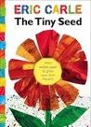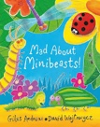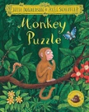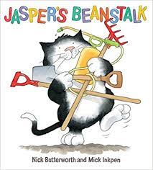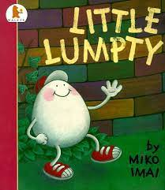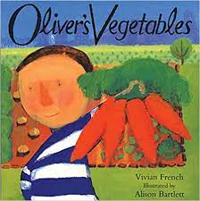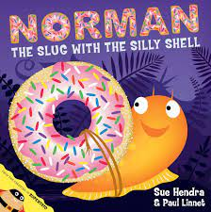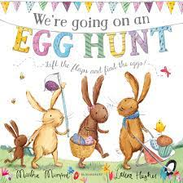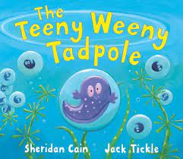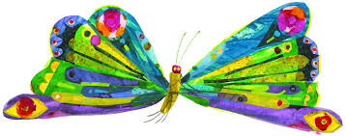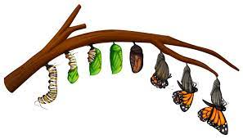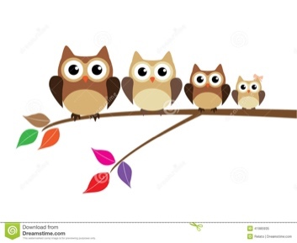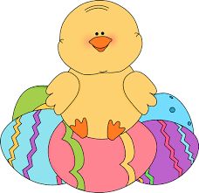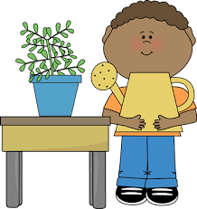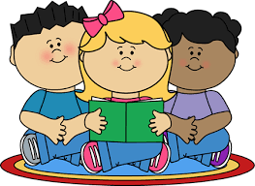

Our main theme for March and April is ‘Growing.’ Children will be able to experience many different learning opportunities across all areas of the curriculum. Some will be ‘teacher led’ but most will involve children learning, investigating and problem solving for themselves.

We will also be engaging in some ‘Easter’ activities such as decorating eggs and Easter artwork.

We will be measuring children for height and making using language around size and comparison. We will discuss how we

grow and the transformation from babies through to adults.

**Our Core Books will be:**

We will also look at animals and their babies and the similarities

and differences of these.

Our caterpillars from ‘Insect Lore’ will also be arriving soon. This gives us great opportunities to observe the cycle of growing that they go through before transforming into butterflies. Children also learn about frogs and tadpoles and their lifecycle too.

Children will be given opportunities to look at plants and food that we grow and how we prepare them to eat. They will be able to plant and explore different aspects of gardening such as different types of seeds, soil, and gardening equipment. Much artwork is also involved ‘such as still’ life paintings of flowers for example.

**Key focus:** things that grow- flowers, plants and food; animals, insects and people.

**Growing in my wonderful world!**

