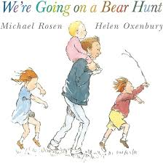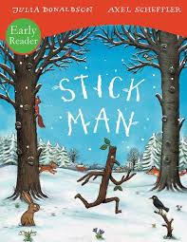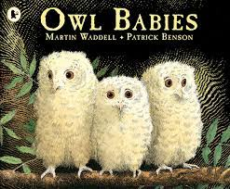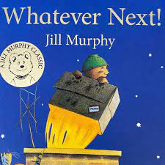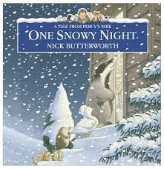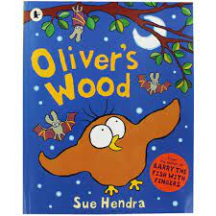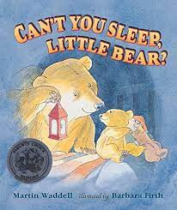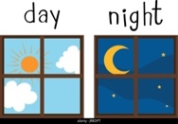

Children will also have opportunities to learn about and create ‘Valentine’s Day’ themed artwork to get a simple understanding of this tradition.

As part of our ‘World Around Us’ curriculum we discover with the children how people in other cultures celebrate their ‘Lunar New Year’- often known as ‘Chinese New Year.’ We will be looking at and talking about clothes, food, and customs that children who celebrate this festival may experience.

**Our Core Books will be:**

As part of our creative work children will be exploring colour. They will be investigating how they can mix, change and use it for a variety of purposes.

We will be talking about the season of ‘Winter’. Children will be observing the weather, particularly ice when it occurs. There will be further opportunities to investigate ice and lots of discussion about how it is made and how it melts. We will talk about other aspects of ‘Winter’, such as the clothes we need to wear and why, and what happens to some wild animals when it gets cold (hibernation). We will also investigate snow- if we get some!

Our starting point for this learning will include talking about ‘Night and Day.’ Children will have the chance to think about the differences between the two and develop these ideas in their play. Ideas such as different clothing, bedtime and morning routines, daylight and getting dark at nighttime will form part of our discussions.

In January and February, we will be learning about “Things that Change.” Children will investigate, learn and discover through many different learning and development opportunities.

**Key focus:** Night and day; changing and mixing colours; cooking and baking; melting and freezing

**Time and change**

**I see around me**

